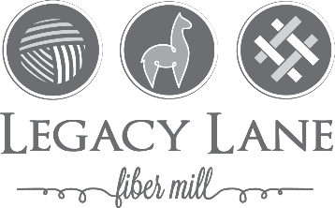

(Please insert one in each bag)

Name:____________________________

Farm Name:_________________________

__________________________________

Shipping Method/Destination:______________

__________________________________
Phone #:____________________________

Bag Identifier: (ex. name / lot #)

__________________________________

Fiber Information:

Blanket Neck/Legs

Length:___________

Grade and/or Micron:___________

End Product (please circle)

Roving Batting Rug Yarn

Knotty ‘n’ Nice Felt

Felt for Insoles Lopi Yarn

Yarn Ply______ YYP________

Blending Fibers (please circle)

Merino ________%

Bamboo ________%

Hemp ________%

Nylon ________%

Specific requests and intended use of this product:
__________________________________

__________________________________

(Please insert one in each bag)

Name:____________________________

Farm Name:_________________________

__________________________________

Shipping Method/Destination:______________

__________________________________
Phone #:____________________________

Bag Identifier: (ex. name / lot #)

__________________________________

Fiber Information:

Blanket Neck/Legs

Length:___________

Grade and/or Micron:___________

End Product (please circle)

Roving Batting Rug Yarn

Knotty ‘n’ Nice Felt

Felt for Insoles Lopi Yarn

Yarn Ply______ YYP________

Blending Fibers (please circle)

Merino ________%

Bamboo ________%

Hemp ________%

Nylon ________%

Specific requests and intended use of this product:
__________________________________

__________________________________

(Please insert one in each bag)

Name:____________________________

Farm Name:_________________________

__________________________________

Shipping Method/Destination:______________

__________________________________
Phone #:____________________________

Bag Identifier: (ex. name / lot #)

__________________________________

Fiber Information:

Blanket Neck/Legs

Length:___________

Grade and/or Micron:___________

End Product (please circle)

Roving Batting Rug Yarn

Knotty ‘n’ Nice Felt

Felt for Insoles Lopi Yarn

Yarn Ply______ YYP________

Blending Fibers (please circle)

Merino ________%

Bamboo ________%

Hemp ________%

Nylon ________%

Specific requests and intended use of this product:
__________________________________

__________________________________

